ANNEX 1

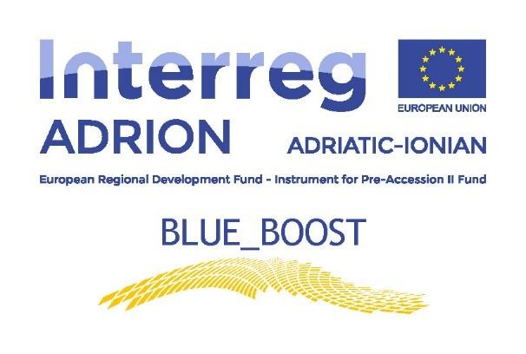

Application Form for the selection of participants at the Blue_Boost Brokerage Event & Transnational Cross-Field Visit, Thessaloniki, Region of Central Macedonia (Greece),
5-6 June 2019

APPLICANT PROFILE
Name of the Applicant
Legal Status
Type of Applicant (MSME, Start – Up, Skilled enterprise (KP), Research - development & innovation organisation, New Innovation Agent, Other)
Possible role of the Applicant in BLUE_BOOST pilot action (please choose) | MSME / Start-Up (potential voucher beneficiary) □  Knowledge Provider (KP) □
Address (if the legal seat is not in the Puglia Region, please provide also the address of the branch in this pilot Region)
Website, E-mail and Phone number

VAT or other national identifying number (if no VAT number is provided)
Business activities - NACE codes (if available)
Description of the products and services offered
Technology applied
Turnover in the last 3 years
Number of employed people
Participation to Clusters, Networks or Flags
Quality Certifications
Previous participation to local, national or international projects
Legal representative name
Legal representative contact
(E-mail and Phone number)
Participant name
Participant contact (E-mail and Phone number
Role in the applicant organisation

MOTIVATIONS AND EXPECTATIONS
Main reasons for participating to the Brokerage Event and the Cross - Field Visit
Main expectations from the participation to the Brokerage Events and the Cross- Field Visit

Place and date
Signature of legal representative

I hereby agree for processing the personal information included in this application form strictly for the purposes of this selection and in accordance with the regulation for the protection of personal data Regulation (EU) 2016/679 – GDPR.

Treatment of personal data will follow the principles of fairness and transparency according to Regulation (EU) 2016/679 – GDPR and the subsequent national transposing laws. Details about the document to be submitted and the treatment of personal data are provided at annex 6.

Applicant’s Declaration
for the selection of the participants to the
Brokerage Event and Blue_Boost Cross-Field Visits programme

The undersigned

Surname

Name

Born in
on

Living in

Address nr
Postal code

Phone number Mobile

e-mail

in my capacity as the legal representative of

Name of the applicant organization

Address nr
Postal code

Phone number

e-mail

website

VAT or other national identifying number (if no VAT number is provided)_

Require

to be admitted to participation to the Brokerage Event and the Cross-Field Visit in Thessaloniki – Central Macedonia (Greece) on the 5th and 6th of June 2019

To this end declare:
All information concerning the participation of my organization in the Brokerage Event and the Cross-Field Visit in Thessaloniki – Central Macedonia (Greece), as enclosed in the application form, has been verified and it is true and correct;

• As far as the above mentioned Brokerage Event and Cross-Field Visit and the related tasks are concerned, my organization will be represented by:

Surname

Name

Born in

on

Living in
_

Address nr
Postal code

Phone number Mobile

e-mail

Role in the organization

- I give full mandate to (name and surname of the participant) to participate to the above mentioned Brokerage Event & Cross-Field Visit for representing my organization;
- (name and surname of the participant) have the following level of knowledge
of the English Language (mark with an X the level held for each type)

 | Listening and reading | Speaking | Writing
BASE
MEDIUM
ADVANCED

- (name and surname of the participant) has appropriate and valid documents for travelling in Greece (here-to attached) at the date of submission of the application and for the duration of the Brokerage Event & Cross-Field Visit;
- The undersigned declares to have taken note of the notice/announcement and that, if selected to benefit the Blue_Boost Brokerage Event & Cross-Field Visits programme, will fill-in at the end of the experience, 2 brief reports/questionnaires on their activities, the competence acquired, the possibility of transfer the same in their own contexts (Annexes 4 & 5).
- The applicant organisation agrees to allow BLUE_BOOST partners to process the data given solely for the project needs (including publishing of general information) and statistical reasons, even through electronic or computerised devices, in respect of the security and privacy within the law.

Place and Date…………………………… Signature……………………………….

