ANNEX 5

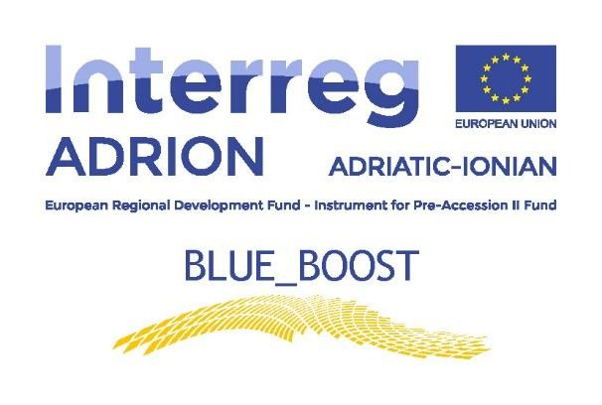

BOOSTing the innovation potential of the triple helix of Adriatic-Ionian traditional and emerging BLUE growth sectors clusters through an open source/knowledge sharing and community based approach

Blue Boost Transnational Brokerage Event at Thessaloniki
Evaluation questionnaire



- What is your country of origin

□Albania
□Croatia
□Greece
□Italy
□Other (Please specify) …………………………………………..

- What is your role in the project?

□Blue Boost Project member
□Local Innovation Committee (LIC)
□Knowledge Provider (KP)
□Blue SME
□Other (Please specify) …………………………………………..

- What´s your level of satisfaction on the following points

 | Not  satisfied | Satisfied | Very  satisfied | I don't have a clear answer  Or  I was not in that part of the event
The information received before the event was good enough? (Purpose of the event, type of participants, clarity on the agenda, etc.)

Were the information and objectives explained and the activities developed during the event clear?

Were any Business Collaboration opportunities arisen from the event?
Was the time of each activity well balanced?

Facilities and venue of the event

Catering services provided
Overall experience from the event

- Were the B2B meetings among KP & SME interesting? What would you improve
or comment regarding their organization?
…………………………………………………………………………………………………………………………
…………………………………………………………………………………………………………………………
…………………………………………………………………………………………………………………………

- What did you gain most from this event?
…………………………………………………………………………………………………………………………
…………………………………………………………………………………………………………………………
…………………………………………………………………………………………………………………………

- Do you have any additional recommendations towards the improvement of future
similar events?

…………………………………………………………………………………………………………………………
…………………………………………………………………………………………………………………………
…………………………………………………………………………………………………………………………

