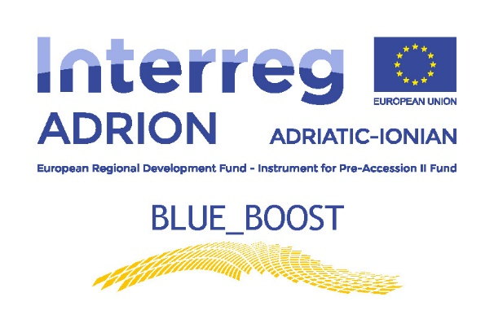

Activity T3.3 - B_B Transnational Cross-Field Visits

Expression of Interest for the selection of the participants to the Blue_Boost Cross-Field Visit in Greece
05.12.2018
Activity T3.3 - B_B Transnational Cross-Field Visits

The Blue_Boost Cross-Field Visits Programme is composed by a cycle of 7 transnational cross-field visits - 5 back-to-back with the Blue_Boost Steering Committee meetings and Final Event and 2 as stand-alone actions, for “in loco understanding” of:
- innovation structures,
- successful showcases,
- initiatives of interaction and cooperation among local institutional/non-institutional innovation actors working in traditional and emerging maritime sectors.

The 7 Blue_Boost target maritime regions can offer different, but complementary potential of transnational networking inspiring solutions and new concepts of transboundary and cross sectoral fertilization, bench learning and best practices sharing. Therefore, the aim of the Cross Field Visits Programme is to put into connection the different maritime stakeholders from the Blue_Boost areas in order to upgrade concretely their international innovation cooperation capacity, as well as to accelerate and facilitate their aggregation at local level.

Accordingly, the 7 delegations are composed of:
- Project Partners (PPs);
- Observers Groups (Associated Project Partners - ASPs)
- Institutional/not- institutional maritime actors from Blue_Boost target regions.

The participants are selected by PPs – at local level - thanks to a public Expression of Interest (EoI): winners are awarded with “B_B” travel fiches. Observers Groups (ASPs) will participate only in Cross-Field Visits in Central Macedonia, Albania and Marche Region.

GENERAL CONDITIONS FOR STAKEHOLDERS’ SELECTION
A procedure is called for assessing applications based application forms and possible interviews for the selection of n. 04 candidates that will participate in the Cross-Field Visit in Patras – Greece. ARTI reserves the right to increase the number of places available.
The visits, which will take place on 05.12.2018, will be organized by the Patras Science Park S.A. and will regards relevant companies operating in the aquaculture and fisheries clusters.
In the selection, particular attention will be paid for ensuring equal opportunity, non-discrimination and equality between men and women.

REQUIREMENTS FOR THE APPLICANTS
1. Applicants must be private bodies (professionals included) or public bodies or governance bodies (public administration), research bodies and innovation actors active in the field of fisheries & aquaculture.
2. Applicants must have their headquarters or an operative branch in Puglia Region.
3. Participants (applicants’ representative) must:
o be at least eighteen years old at the date of submission of the application;
o have appropriate and valid documents for travelling in Greece at the date of submission of the application and for the entire duration of the Cross-Field Visit;
o be provided with a declaration signed by the legal representative of the applicant, giving mandate to the participant to represent the applicant within the Cross-Field Visit;
o have a good level of knowledge of English.

SUBMISSION OF APPLICATIONS
- Deadlines: Applications, written on plain paper using the form enclosed with this notice (Annex I), must be sent no later than the day 20.11.2018 at 1 PM to the attention of Mrs Francesca Tondi to the email address arti@pec.rupar.puglia.it. Applications must be sent on-line as PDF bearing the signature of the legal representative on both the application form and any attachment. Applications received after the date indicated above will be excluded from the selection.
- Documents to send:
  - Application form describing the activities carried out in the sectors concerned, including the declaration by the legal representative of the applicant signed by the applicant’s legal representative (Annex I).
  - Scanned photocopy front and back of a valid identity document of the legal representative.

PHASES AND CRITERIA OF SELECTION

EVALUATION – ARTI will nominate a commission of three members. The commission will evaluate the profile of the applicants, as well as their motivations and expectations for participating in the Cross-Field Visit. The selection will take place according to the following procedure:
1. Analysis of the documentation with respect to:
- Compliance with the requirements;
- Contents and motivations expressed in the application form
2. Should the analysis of the documentation not enable the selection of participants, the commission will carry out individual interviews with eligible candidates to evaluate: a) Motivations and expectations expressed to take part in the project; b) Level of knowledge of one or more foreign languages; c) Training and professional experience related to the project topics. In this case, the list of candidates admitted to the selection, as well as dates, times, and locations of the interviews will be published on the ARTI website, in addition to a direct notification to candidates via e-mail. Candidates must have a valid identity document to make the interview. As a final step, the commission will draw up a list of selected participants that will be communicated to all applicants, as well as published on the website.

AGREEMENT WITH THE PROJECT PARTNER - Each participant must sign an agreement with ARTI with which it undertakes to participate in the Cross-Field Visit and the related tasks.

FINAL REPORT - Each participant organization will also assume the obligation to write, at the end of the experience, a report on its activities, the competence acquired, the possibility of transfer the same in their own contexts, based on the form attached to these ToR as Annex II.

COSTS COVERED BY CROSS-FIELD VISIT PROGRAM
The funding covers the cost for 1 participant for each selected applicant organization, up to a maximum of 450 EUR per participant, through the contribution of the ADRION Programme, including:
- Travel from the legal seat of the organization to the Cross-Field Visit venue and back (business or first class is not eligible);
- Accommodation (5 stars hotels are not eligible);
- Meals if not provided by the hosting organization (Costs for alcoholic beverages are not eligible).
- Local transports (taxi is not eligible except when it can be demonstrated that no public transport was available at the time and place needed).

There is no fee to participants or any refund or recognition of the hourly cost to the selected organization. The reimbursement of the incurred costs will be issued just through the presentation of the Reimbursement Form provided by ARTI, with annexed the proof of expenditures (invoices, tickets, bills, etc.) in original copy.

The provision of data is mandatory for the purposes of this selection and in accordance with the regulation for the protection of personal data Regulation (EU) 2016/679 – GDPR.
Treatment of personal data will follow the principles of fairness and transparency according to Regulation (EU) 2016/679 – GDPR and the subsequent national transposing laws. Details about the document to be submitted and the treatment of personal data are provided at Annex III.

Apulia, Marche and Friuli Venezia Giulia Regions in Italy; Western Greece and Central Macedonia in Greece; Zadar County in Croatia; coastal areas of Durres, Vlora, Saranda and Shengjin in Albania.

